Create Master/Detail

There are 2 options:

1. Create new Master/Detail Project (Will create for tutorial)
2. Add to existing project

Source:

Create New Master/Detail Project (Menu/YouTube Video)

1. File > New >Project > Master-Detail Application > Next
2. Name your project

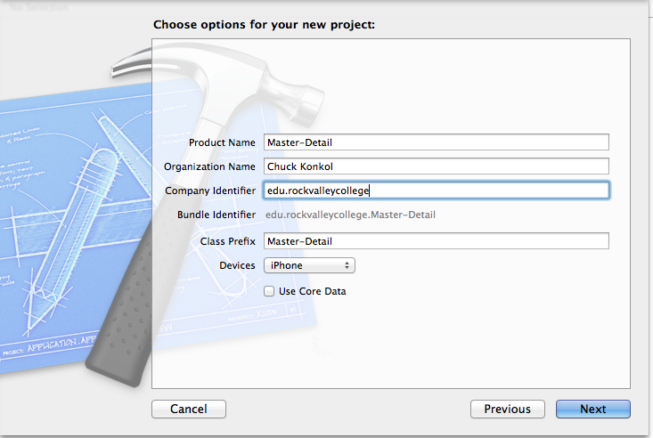

1. NEXT > CREATE

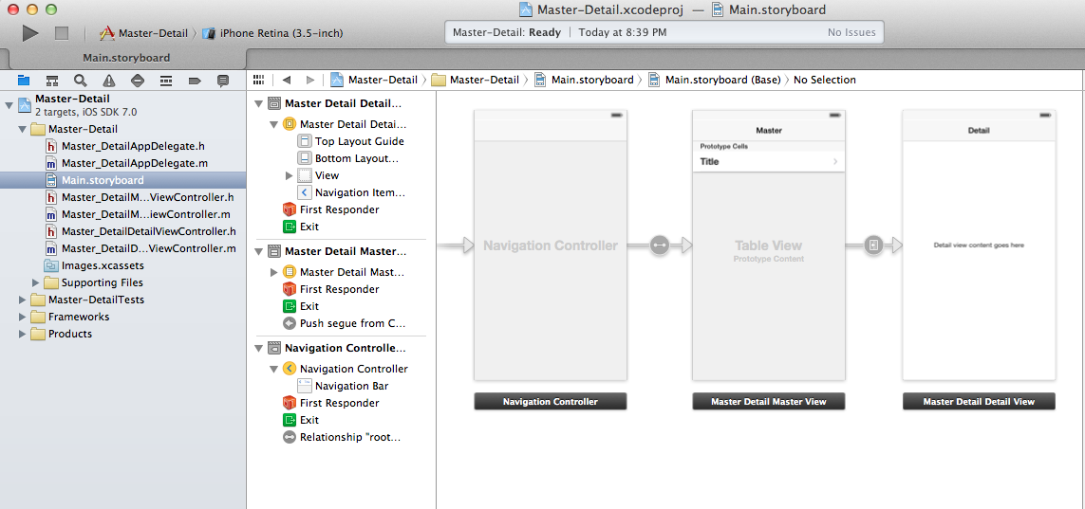

1. We need to delete the label on DetailView

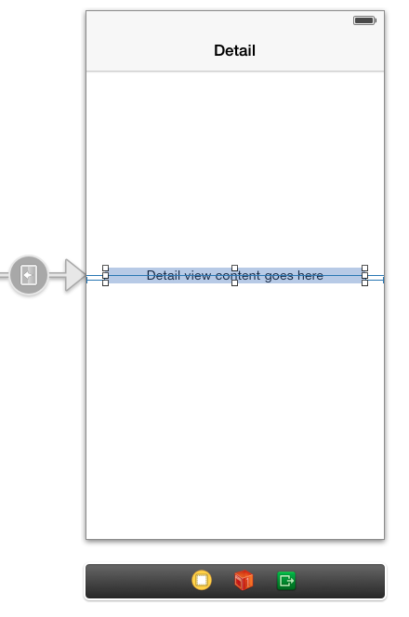

1. Complete MasterDetail.h

// Master_DetailMasterViewController.h

// Master-Detail

//

// Created by Charles Konkol on 10/6/13.

// Copyright (c) 2013 Chuck Konkol. All rights reserved.

//

#import <UIKit/UIKit.h>

@interface Master_DetailMasterViewController : UITableViewController

{

NSArray *Master;

NSArray *Detail;

}

@property (strong, nonatomic) NSArray *Master;

@property (strong, nonatomic) NSArray *Detail;

@end

1. Add webbrowser and activity indicator view to DetailView
   * CTRL + Drag webbrowser to .h and name **webview**
   * CTRL + Drag ActivityIndicator to .h and name **am**

1. Complete DetailView.m

//

// Master_DetailMasterViewController.m

// Master-Detail

//

// Created by Charles Konkol on 10/6/13.

// Copyright (c) 2013 Chuck Konkol. All rights reserved.

//

#import "Master_DetailMasterViewController.h"

#import "Master_DetailDetailViewController.h"

@interface Master_DetailMasterViewController () {

NSMutableArray *_objects;

}

@end

@implementation Master_DetailMasterViewController

@synthesize Master,Detail;

NSString *mycis,*cisapps,*cisco;

- (void)viewDidLoad

{

[super viewDidLoad];

// Do any additional setup after loading the view, typically from a nib.

}

- (void)awakeFromNib

{

[super awakeFromNib];

}

//Loads each time page is visited

//Checks if internet is connected

-(void)viewWillAppear:(BOOL)animated

{

if([self checkinternet] == NO)

{

// Not connected to the internet

self.title = @"CIS Videos";

UIAlertView *message = [[UIAlertView alloc] initWithTitle:@"Internet Connection Required"

message:@"Close app and return when internet connection available."

delegate:nil

cancelButtonTitle:@"OK"

otherButtonTitles:nil];

[message show];

}

else

{

[self LoadPage];

}

}

//Check Internet

- (BOOL) checkinternet

{

NSURL *scriptUrl = [NSURL URLWithString:@"http://www.google.com/m"];

NSData *data = [NSData dataWithContentsOfURL:scriptUrl];

if (data)

{

NSLog(@"Device is connected to the internet");

return YES;

}

else

{

NSLog(@"Device is not connected to the internet");

return NO;

}

}

//Load Page

- (void) LoadPage

{

self.title = @"CIS Videos";

NSArray *MasterArray = [[NSArray alloc] initWithObjects:@"MYCIS", @"CIS APPS", @"CISCO",nil];

self.Master = MasterArray;

//Check if iPad or iPhone

if ([[UIDevice currentDevice] userInterfaceIdiom] == UIUserInterfaceIdiomPhone) {

[self setupMainView_iPhone];

}

else {

[self setupMainView_iPad];

}

}

//If iphone

- (void) setupMainView_iPhone

{

mycis = @"<iframe webkit-playsinline width=\"680\" height=\"383\" src=\"http://www.youtube.com/embed/mlMiQONvxCA?feature=player_detailpage\" frameborder=\"0\" allowfullscreen></iframe>";

cisapps = @"<iframe webkit-playsinline width=\"680\" height=\"383\" src=\"http://www.youtube.com/embed/j-vcZqTWKuc?feature=player_detailpage\" frameborder=\"0\" allowfullscreen></iframe>";

cisco = @"<iframe webkit-playsinline width=\"680\" height=\"383\" src=\"http://www.youtube.com/embed/7XeYggGAxj0?feature=player_detailpage\" frameborder=\"0\" allowfullscreen></iframe>";

NSArray *DetailArray = [[NSArray alloc] initWithObjects:mycis, cisapps, cisco,nil];

self.Detail = DetailArray;

}

//If iPad

- (void) setupMainView_iPad

{

mycis = @"<iframe webkit-playsinline width=\"960\" height=\"720\" src=\"http://www.youtube.com/embed/mlMiQONvxCA?feature=player_detailpage\" frameborder=\"0\" allowfullscreen></iframe>";

cisapps = @"<iframe webkit-playsinline width=\"960\" height=\"720\" src=\"http://www.youtube.com/embed/j-vcZqTWKuc?feature=player_detailpage\" frameborder=\"0\" allowfullscreen></iframe>";

cisco = @"<iframe webkit-playsinline width=\"960\" height=\"720\" src=\"http://www.youtube.com/embed/7XeYggGAxj0?feature=player_detailpage\" frameborder=\"0\" allowfullscreen></iframe>";

NSArray *DetailArray = [[NSArray alloc] initWithObjects:mycis, cisapps, cisco,nil];

self.Detail = DetailArray;

}

- (void)didReceiveMemoryWarning

{

[super didReceiveMemoryWarning];

// Dispose of any resources that can be recreated.

}

- (void)insertNewObject:(id)sender

{

if (!_objects) {

_objects = [[NSMutableArray alloc] init];

}

[_objects insertObject:[NSDate date] atIndex:0];

NSIndexPath *indexPath = [NSIndexPath indexPathForRow:0 inSection:0];

[self.tableView insertRowsAtIndexPaths:@[indexPath] withRowAnimation:UITableViewRowAnimationAutomatic];

}

#pragma mark - Table View

- (NSInteger)numberOfSectionsInTableView:(UITableView *)tableView

{

return 1;

}

- (NSInteger)tableView:(UITableView *)tableView numberOfRowsInSection:(NSInteger)section

{

return [Master count];

}

- (UITableViewCell *)tableView:(UITableView *)tableView cellForRowAtIndexPath:(NSIndexPath *)indexPath

{

static NSString *CellIdentifier = @"Cell";

UITableViewCell *cell = [tableView dequeueReusableCellWithIdentifier:CellIdentifier];

cell.textLabel.text = [Master objectAtIndex:[indexPath row]];

return cell;

}

- (BOOL)tableView:(UITableView *)tableView canEditRowAtIndexPath:(NSIndexPath *)indexPath

{

// Return NO if you do not want the specified item to be editable.

return YES;

}

- (void)tableView:(UITableView *)tableView commitEditingStyle:(UITableViewCellEditingStyle)editingStyle forRowAtIndexPath:(NSIndexPath *)indexPath

{

if (editingStyle == UITableViewCellEditingStyleDelete) {

[_objects removeObjectAtIndex:indexPath.row];

[tableView deleteRowsAtIndexPaths:@[indexPath] withRowAnimation:UITableViewRowAnimationFade];

} else if (editingStyle == UITableViewCellEditingStyleInsert) {

// Create a new instance of the appropriate class, insert it into the array, and add a new row to the table view.

}

}

/*

// Override to support rearranging the table view.

- (void)tableView:(UITableView *)tableView moveRowAtIndexPath:(NSIndexPath *)fromIndexPath toIndexPath:(NSIndexPath *)toIndexPath

{

}

*/

/*

// Override to support conditional rearranging of the table view.

- (BOOL)tableView:(UITableView *)tableView canMoveRowAtIndexPath:(NSIndexPath *)indexPath

{

// Return NO if you do not want the item to be re-orderable.

return YES;

}

*/

- (void)prepareForSegue:(UIStoryboardSegue *)segue sender:(id)sender

{

[segue.destinationViewController setURL:[Detail objectAtIndex:[self.tableView.indexPathForSelectedRow row]]];

[segue.destinationViewController setCaption:[Master objectAtIndex:[self.tableView.indexPathForSelectedRow row]]];

}

@end

1. Complete DetailView.h

//

// Master_DetailDetailViewController.h

// Master-Detail

//

// Created by Charles Konkol on 10/6/13.

// Copyright (c) 2013 Chuck Konkol. All rights reserved.

//

#import <UIKit/UIKit.h>

@interface Master_DetailDetailViewController : UIViewController <UIWebViewDelegate>

{

//1) Add Default initializers

NSString *URL;

NSString *Caption;

}

@property (strong, nonatomic) IBOutlet UIActivityIndicatorView *am;

//2) Modify.

//This will get rid of error on MasterViewConrtoller:

//- (void)prepareForSegue:

@property (strong, nonatomic) NSString *URL;

@property (strong, nonatomic) NSString *Caption;

@property (strong, nonatomic) IBOutlet UIWebView *webview;

@end

1. Complete DetailView.m

//

// Master_DetailDetailViewController.m

// Master-Detail

//

// Created by Charles Konkol on 10/6/13.

// Copyright (c) 2013 Chuck Konkol. All rights reserved.

//

#import "Master_DetailDetailViewController.h"

@interface Master_DetailDetailViewController ()

@end

@implementation Master_DetailDetailViewController

//Sythesize

@synthesize webview,URL,Caption,am;

#pragma mark - Managing the detail item

- (void)viewDidLoad

{

[super viewDidLoad];

}

//will load when page is visted

//check internet

-(void)viewWillAppear:(BOOL)animated

{

if([self checkinternet] == NO)

{

// Not connected to the internet

self.title = @"CIS Videos";

UIAlertView *message = [[UIAlertView alloc] initWithTitle:@"Internet Connection Required"

message:@"Close app and return when internet connection available."

delegate:nil

cancelButtonTitle:@"OK"

otherButtonTitles:nil];

[message show];

}

else

{

[self LoadPage];

}

}

//load webview with YouTube video

- (void) LoadPage

{

[self.webview setDelegate:self];

[am startAnimating];

self.title = Caption;

[webview setAllowsInlineMediaPlayback:YES];

[[self webview]loadHTMLString:URL baseURL:nil];

}

//Stop animation

-(void) webViewDidFinishLoad:(UIWebView *)webView

{

if ([[webView stringByEvaluatingJavaScriptFromString:@"document.readyState"] isEqualToString:@"complete"]) {

// UIWebView object has fully loaded.

[am stopAnimating];

}

}

- (void)didReceiveMemoryWarning

{

[super didReceiveMemoryWarning];

// Dispose of any resources that can be recreated.

}

- (BOOL) checkinternet

{

NSURL *scriptUrl = [NSURL URLWithString:@"http://www.google.com/m"];

NSData *data = [NSData dataWithContentsOfURL:scriptUrl];

if (data)

{

NSLog(@"Device is connected to the internet");

return YES;

}

else

{

NSLog(@"Device is not connected to the internet");

return NO;

}

}

@end

1. Uncheck AutoLayout
2. Activity Indicator
   * Position Top Center
   * Attributes Inspector
     1. Style: Large White
     2. Color: Pink
     3. Check “Hides When Stopped”
   * 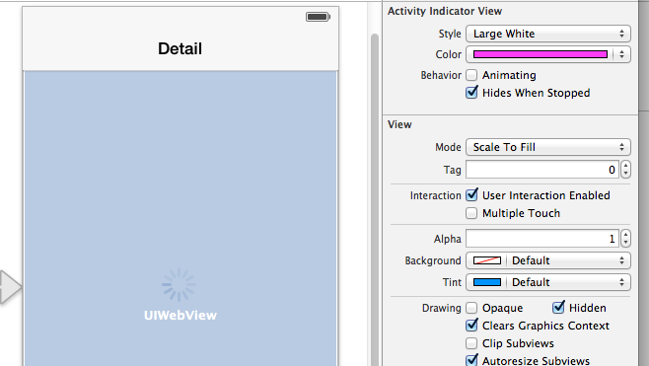
3. Change Device to Layout and accept prompt to convert to iPad
   * 